How to Prepare an In-House Ear Cytology in Veterinary Practices

In veterinary medicine, one of the most common ailments reported from clients are ear infections. Caused by allergies, bacteria, or moisture in the ear, ear infections can be extremely uncomfortable (and even painful) for our furry friends. In order to diagnose such an infection, it is important to know how to set up an ear cytology for viewing the cause of this discomfort. This way, we can properly diagnose the type of infection present and what medications to treat it with.

To set up an ear cytology, you will need:
- Two cotton swabs
- A microscope slide
- A lighter
- KimTech wipes
- Diff-Quik Stains
- A sink
- Bibulous paper (optional)

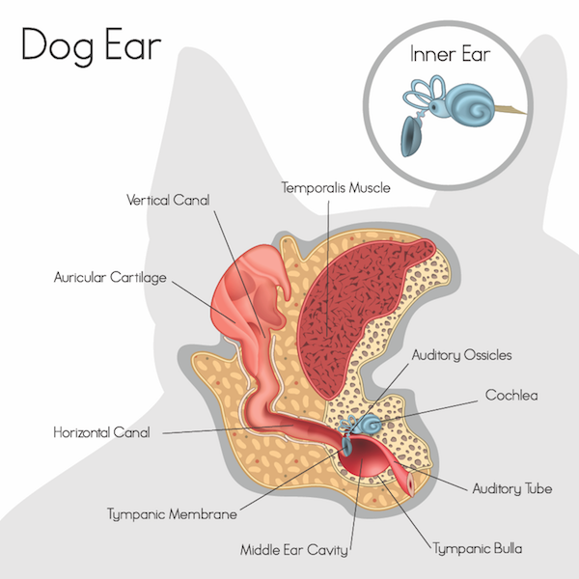
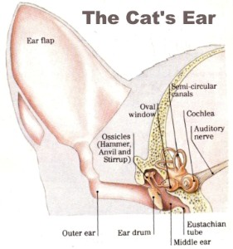
- USE CAUTION: Ear may be painful for patient. Avoid being bit. Collect ear sample from patient by inserting a cotton swab into ear canal of dog or cat. Roll or twist the cotton swab at base of ear canal to ensure generous sample size. Remember that you can never hit a dog or cat’s ear drum because of their “L-shaped” ear canal.

- Once you collect your sample, break the stick of the LEFT cotton swab. This will help you differentiate the left and right samples when viewing under the microscope.

- Roll contents of cotton swab onto a clean microscope slide. Roll the left ear sample on the left side of the slide, and the right ear sample on the right side of the slide.

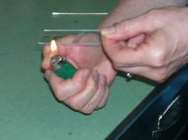
- USE CAUTION. Use care not to be burned by open flame. Heat-fix the sample to the slide by running a flame back and forth under the slide for several seconds. It is normal for the slide to blacken.
Source: sonopath.com

- Wipe blackened side of slide with a clean, dry KimTech wipe.

- Dip slide into the first Diff-Quik fixer stain. Dip the slide into the stain 10 times, resulting in about 10 seconds of contact with the stain. Tap off excess stain from slide.

- Dip slide into the second Diff-Quik stain, using the technique listed in Step 6. Tap off excess stain from slide.
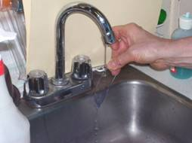
- Dip slide into the third Diff-Quik stain, using the technique from Steps 6 and 7. Tap off excess stain from slide.

- VERY GENTLY rinse stain from slide under running water. Water should run from the top to bottom of the slide. Be careful not to disturb the sample.

- Allow slide to air dry or GENTLY close slide in bibulous paper book to absorb excess water.
- Place slide on microscope. It is ready for viewing.

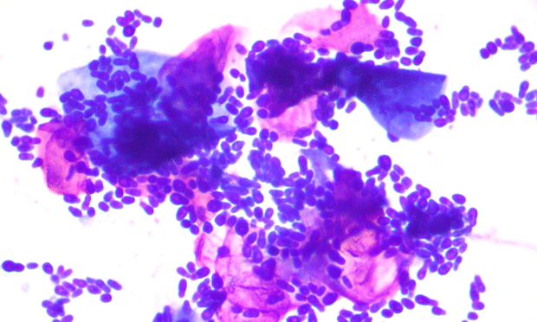
An example of a ear cytology viewed under a microscope.

Source: cliniciansbrief.com

TIPS:

- For your best sample, you may need somebody to hold your patient to keep from wiggling.

- Sample should come from base of ear canal, not the ear flap.

- Distract some patients with treats such as cheese or peanut butter when collecting your sample,

